**NAMEART**

Player/players will be presented with a picture or a figure and will have to choose what

it is representing from multiple choices.

**National Artists**

**1.** 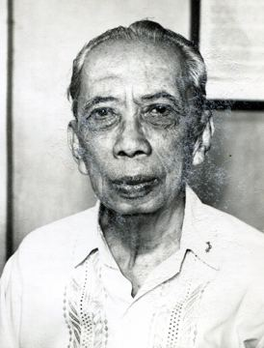

**a.** Fernando Amorsolo **c.** Guillermo Tolentino

**b.** Cirilio Bautista **d.** Lazaro Francisco

**2.** 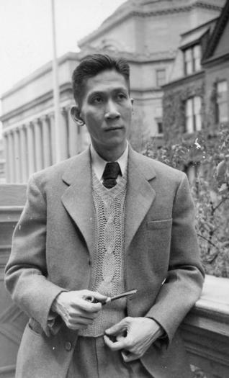

**a.** Jose Garcia Villa **c.** Lucio San Pedro

**b.** Jeremias Elizalde Navarro **d.** Victorio Edades

**3.** 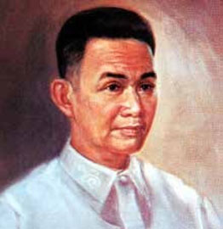

**a.** Antonino Buenaventura **c.** Fernando Amorsolo

**b.** Nick Joaquin **d.** Lino Brocka

**4.** 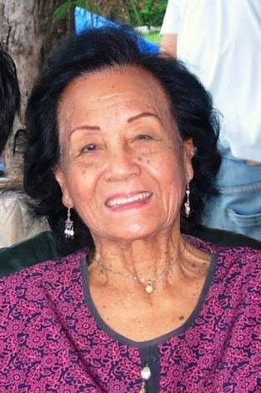

**a.** Lucrecia Reyes-Urtula **c.** Jose Maria Zaragoza

**b.** Leonor Orosa Goquingco  **d.** Edith Tiempo

**5.** 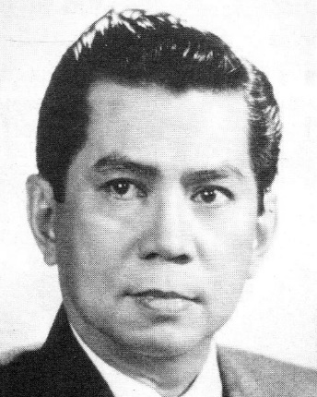

**a.** Lucio San Pedro **c.** Ramon Valera

**b.** Salvador Bernal **d.** Ramon Santos

**6.** 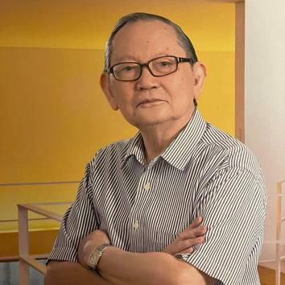

**a.** Arturo Luz **c.** Lazaro Francisco

**b.** Fernando Amorsolo **d.** Jose Joya

**7.** 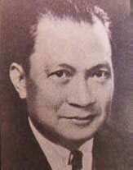

**a.** Juan Nakpil **c.** Abdulmaria Asia Imao

**b.** Lucio San Pedro **d.** Carlos Francisco

**8.** 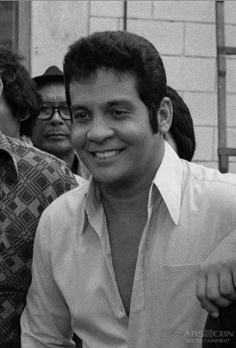

**a.** Ildefonso Santos  **c.** Severino Montano

**b.** Benedicto Cabrera **d.** Ronald Alan K. Poe

**9.** 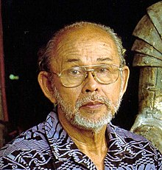

**a.** Wilfrido Ma. Guerrero **c.** Ildefonso Santos

**b.** Ramon Santos **d.** Napoleon Abueva

**10.** 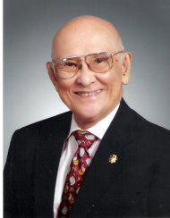

**a.** Ernani Cuenco **c.** Alejandro Roces

**b.** Ramon Obusan **d.** Ildefonso Santos

**11.** 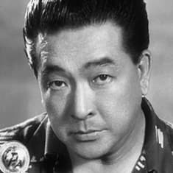

**a.** Manuel Conde  **c.** Felipe Padilla de Leon

**b.** Lamberto Avellana **d.** Victorio Edades

**12.** 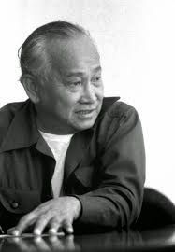

**a.** Cirilio Bautista **c.** Manuel Conde

**b.** Vicente Manansala **d.** Frederico Aguilar Alcuaz

**13.** 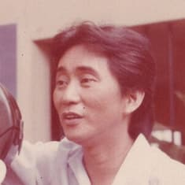

**a.** Hernando Ocampo **c.** Francisco Feliciano

**b.** Ishmael Bernal **d.** Manuel Conde

**14.** 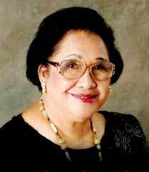

**a.** Lucrecia R. Kasilag **c.** Jovita Fuentes

**b.** Andrea Veneracion **d.** Jose Maria Zaragoza

**15.** 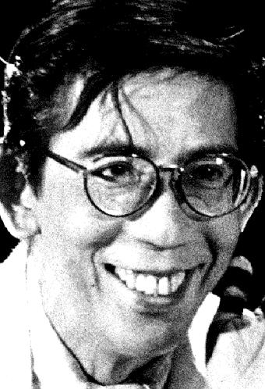

**a.** Hernando Ocampo **c.** Rolando Tinio

**b.** Francisco Feliciano **d.** Frederico Aguilar Alcuaz

**16.** 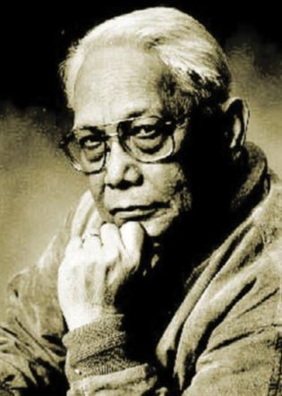

**a.** N.V.M Gonzales **c.** Carlos Francisco

**b.** Hernando Ocampo **d.** Napoleon Abueva

**17.** 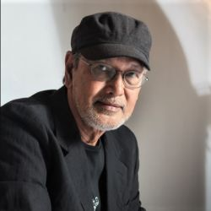

**a.** Nick Joaquin **c.** Hernando Ocampo

**b.** Lamberto Avellana **d.** Benedicto Cabrera

**18.** 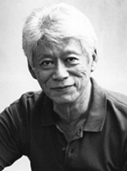

**a.** Jeremias Elizalde Navarro **c.** Gerardo de Leon

**b.** Ang Kiukok **d.** Francisco Coching

**19.** 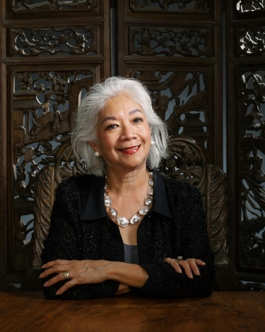

**a.** Francisca Reyes Aquino **c.** Edith Tiempo

**b.** Alice Reyes **d.** Honorata dela Rama

**20.** 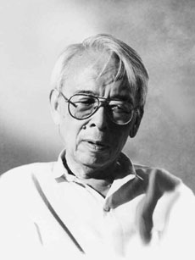

**a.** Gerardo de Leon **c.** Lazaro Francisco

**b.** Francisco Coching **d.** Jose Maceda

**GAMABA**

players will match two

1. 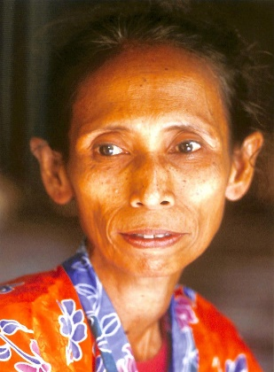

a. Magdalena Gamayo c. Darhata Sawabi

b. Salita Monon d. Haja Amina Appi

2. 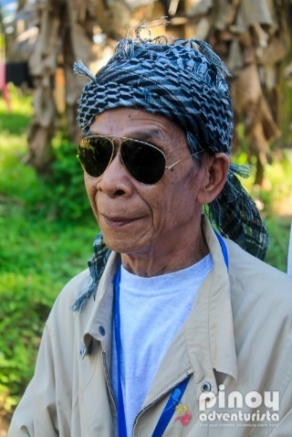

a. Alonzo Saclag c. Uwang Ahadas

b. Federico Caballero d. Ginaw Bilog

3. 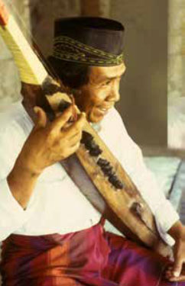

a. Eduardo Mutuc c. Uwang Ahadas

b. Teofilo Garcia d. Samaon Sulaiman

4. 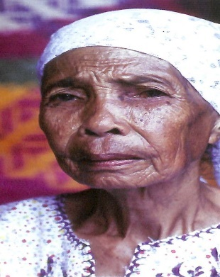

a. Darhata Sawabi c. Samaon Sulaiman

b. Haja Amina Appi d. Lang Dulay

5. 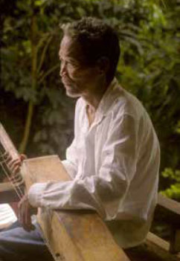

a. Samaon Sulaiman c. Ginaw Bilog

b. Masino Intaray d.

6. 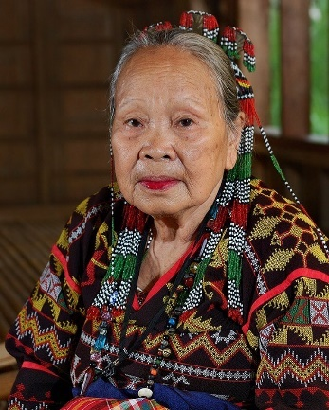

a. Lang Dulay c. Salita Monon

b. Magdalena Gamayo d. Haja Amina Appi

7. 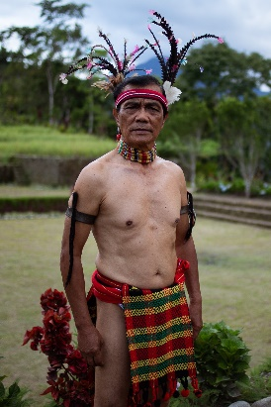

a. Ginaw Bilog c. Alonzo Saclag

b. Federico Caballero d. Haja Amina Appi

8. 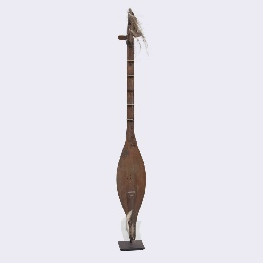

a. Tnalak c. Abel

b. Pis yabit d. Kutyapi

9. 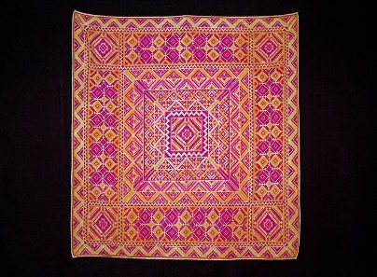

a. Mat c. Tabungaw

b. Pis yabit d. Kutyapi

10. 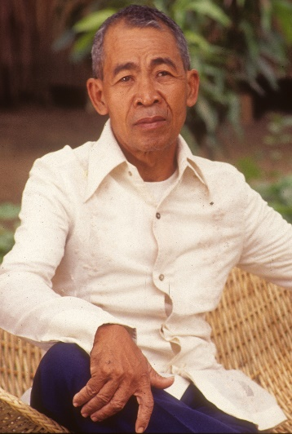

a. Federico Caballero c. Eduardo Mutuc

b. Teofilo Garcia d. Uwang Ahadas

11. 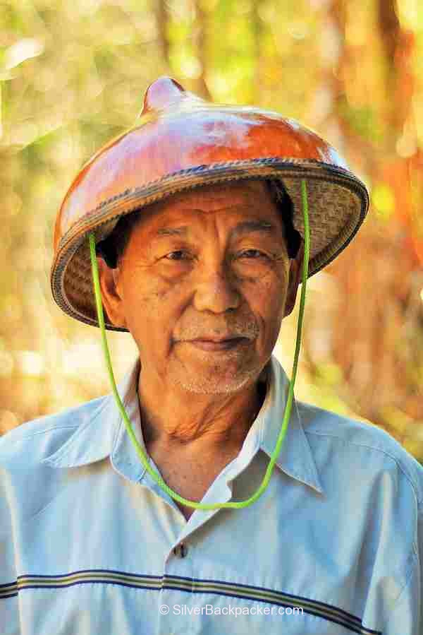

a. Eduardo Mutuc c. Federico Caballero

b. Uwang Ahadas d. Teofilo Garcia

12. 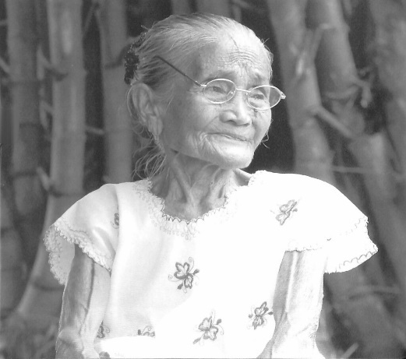

a. Magdalena Gamayo c. Darhata Sawabi

b. Lang Dulay d. Haja Amina Appi

13. 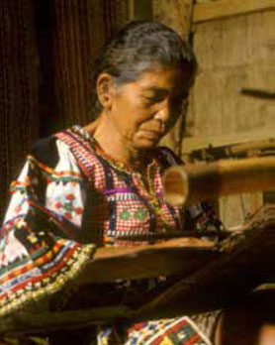

a. Haja Amina Appi c. Salita Monon

b. Lang Dulay d. Darhata Sawabi

14. 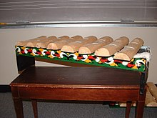

a. Basal c. bagit

b. Kwintangan kayu d. Ambahan

15. 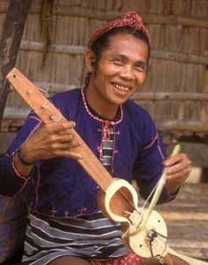

a. Ginaw Bilog c. Alonzo Saclag

b. Federico Caballero d. Masino Intaray

**Contemporary Art Production**

1. 

a. Collage c. Land-art

b. Graffiti d. Digital Art

2. 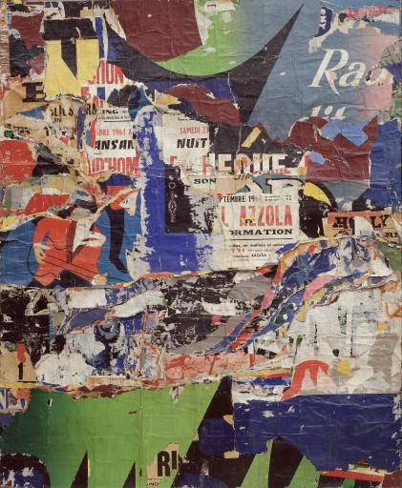

a. Digital Art c. Decollage

b. Decollage d. Graffiti

3. 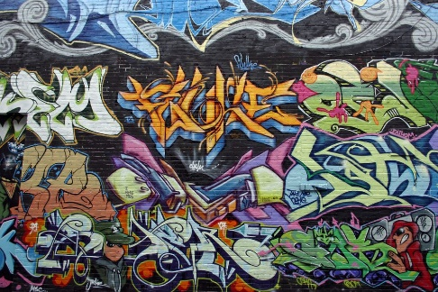

a. Collage c. Digital Art

b. Graffiti d. Land-art

4. 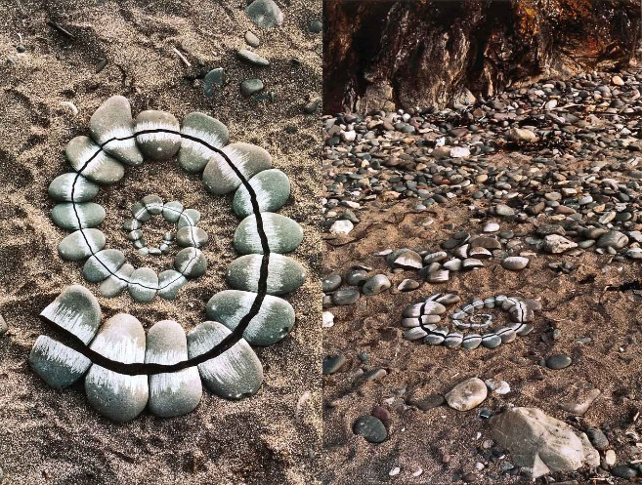

a. Decollage c. Land-art

b. Collage d. Decollage

5. 

a. Decollage c. Graffiti

b. Digital Art d. Digital Art

6. 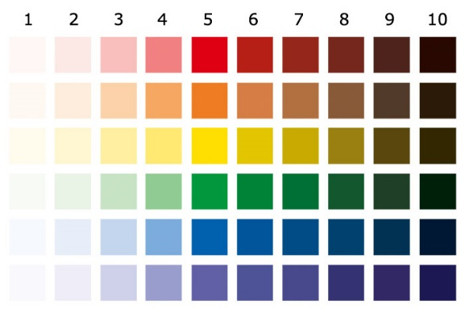

a. brightness c. hue

b. value d. saturation

7. 

a. saturation c. brightness

b. value d. hue

8. 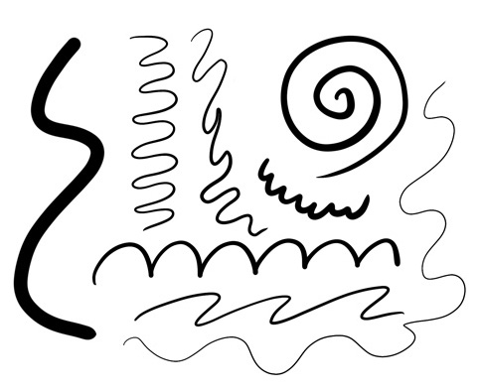

a. color c. lines

b. texture d. shape

9. 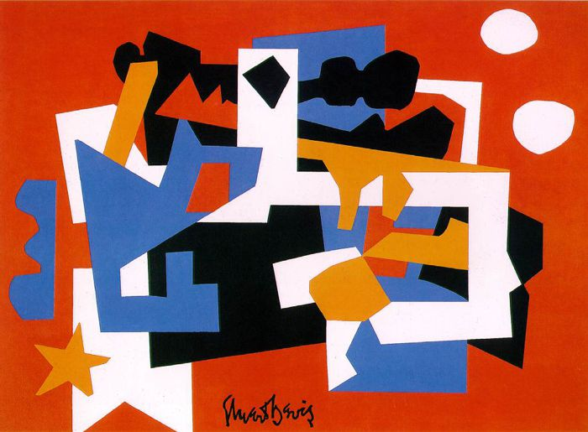

a. shape c. shape

b. lines d. color

10. 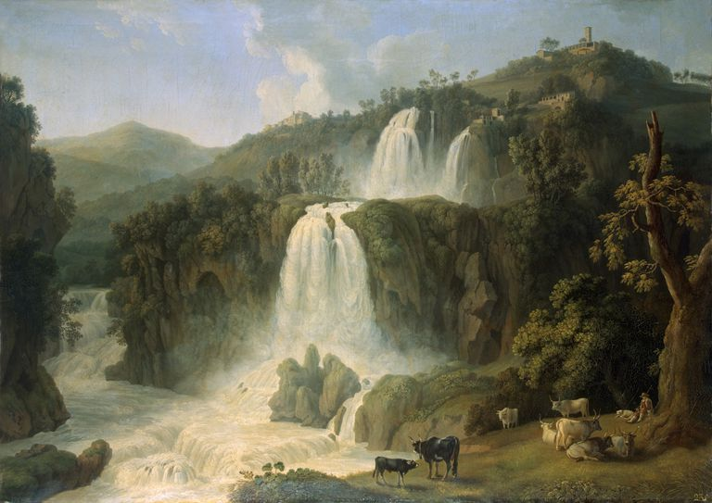

a. portrait c. figures

b. animals d. landscape

**Contemporary Art Forms and Practices**

1. 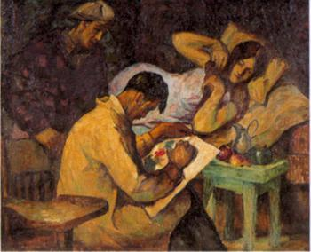

a. Mother and Child by Vicente Manansala c. The Sketch by Victorio Edades

b. Impy Pilapil’s Glass Work d. Nestor Leynes’ Bigas

2. 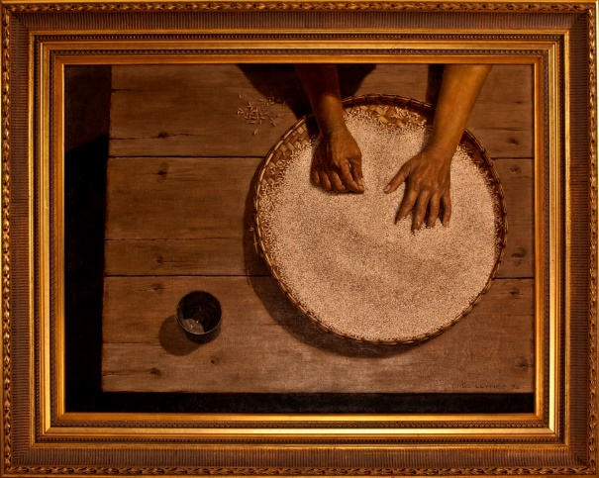

a. The Sketch by Victorio Edades c. Mother and Child by Vicente Manansala

b. Impy Pilapil’s Glass Work d. Nestor Leynes’ Bigas

3. 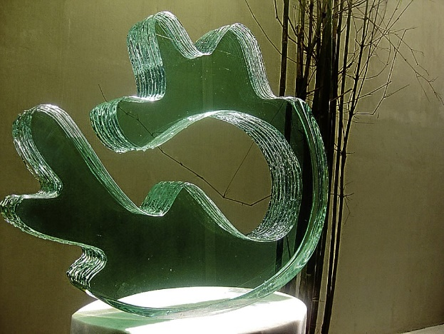

a. Nestor Leynes’ Bigas c. Impy Pilapil’s Glass Work

b. Mother and Child by Vicente Manansala d. The Sketch by Victorio Edades

4. 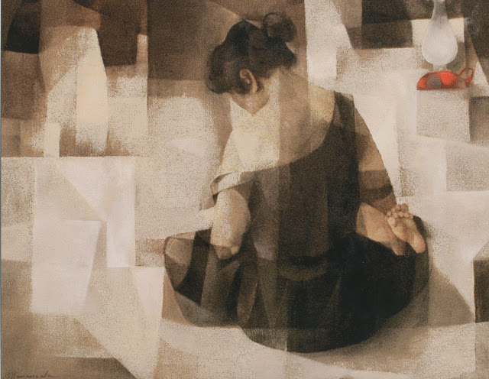

a. Mother and Child by Vicente Manansala c. The Sketch by Victorio Edades

b. Nestor Leynes’ Bigas d. Impy Pilapil’s Glass Work

5. 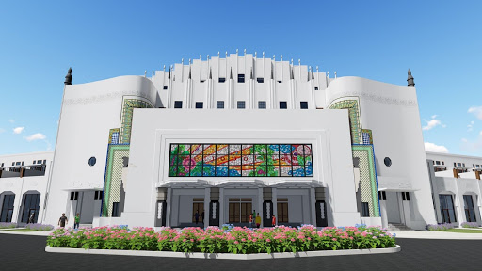

a. Tsalet c. Metropolitan Theater

b. Tinikling d. Theme Park

6. 

a. Metropolitan Theater c. Tinikling

b. Theme Park d. Tsalet

7. 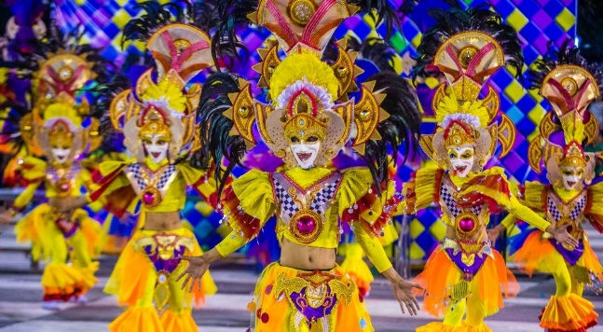

a. Masskara Festival c. Kadayawan Festival

b. Sinulog Festival d. Ati-atihan Festival

8. 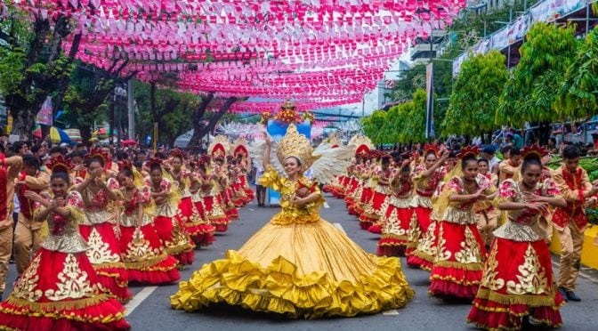

a. Sinulog Festival c. Masskara Festival

b. Ati-atihan Festival d. Kadayawan Festival

9. 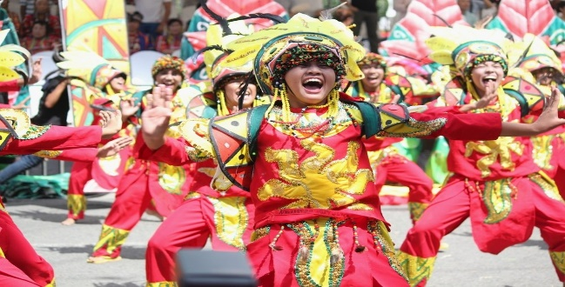

a. Ati-atihan Festival c. Sinulog Festival

b. Kadayawan Festival d. Masskara Festival

10. 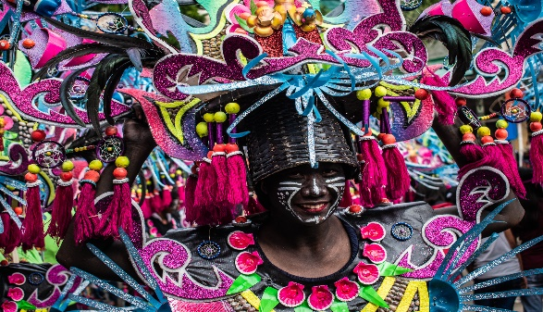

a. Sinulog Festival c. Kadayawan Festival

b. Masskara Festival d. Ati-atihan Festival

**Contemporary Art Techniques and Performance Practices**

1. 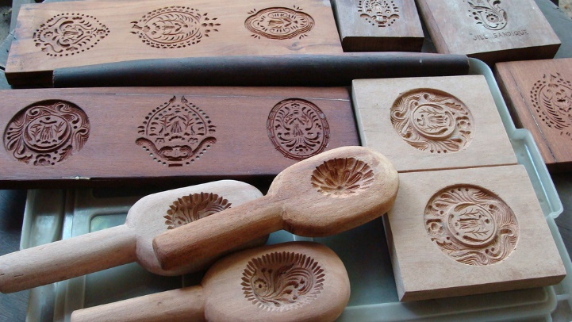

a. Sanikulas Cookie Molds c. Taka

b. Kut-Kut Art d. Pabalot

2. 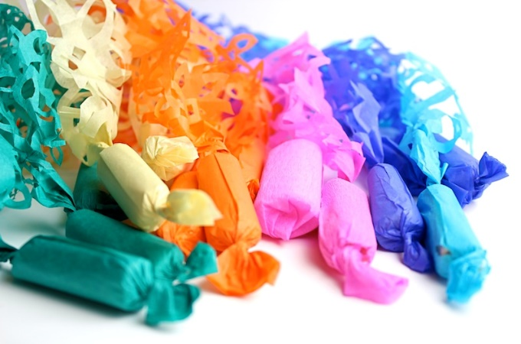

a. Sarimanok c. Pabalot

b. Sanikulas Cookie Molds d. Taka

3. 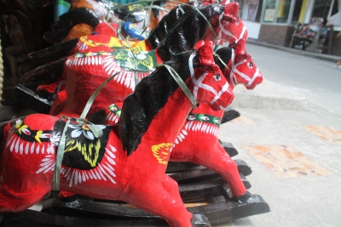

a. Pabalot c. Taka

b. Puni d. Sanikulas Cookie Molds

4. 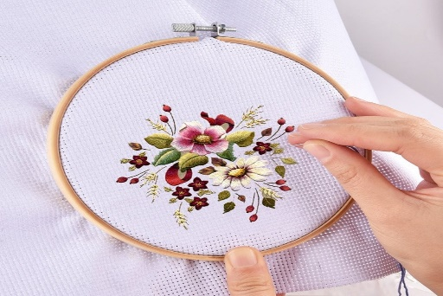

a. Kut-Kut Art c. Bamboo Art

b. Puni d. Pagbuburda

5. 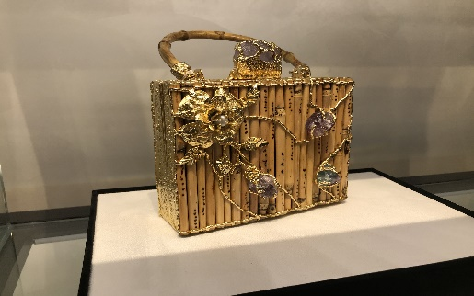

a. Bamboo Art c. Pagbuburda

b. Hagabi d. Malong

6. 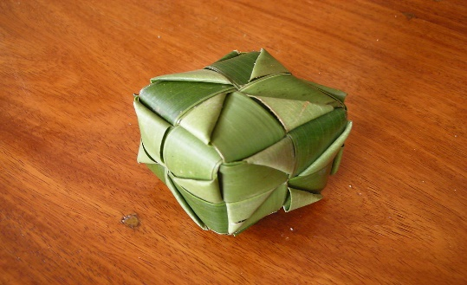

a. Sarimanok c. Malong

b. Puni d. Hagabi

7. 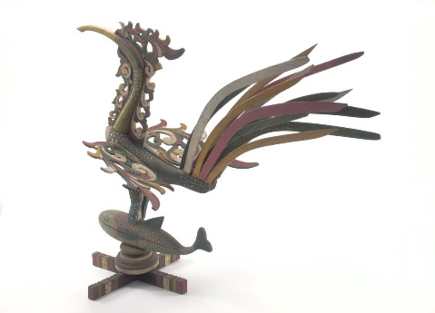

a. Puni c. Hagabi

b. Kut-Kut Art d. Sarimanok

8. 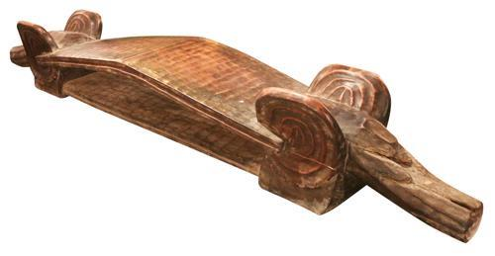

a. Pagbuburda c. Hagabi

b. Kut-Kut Art d. Puni

9. 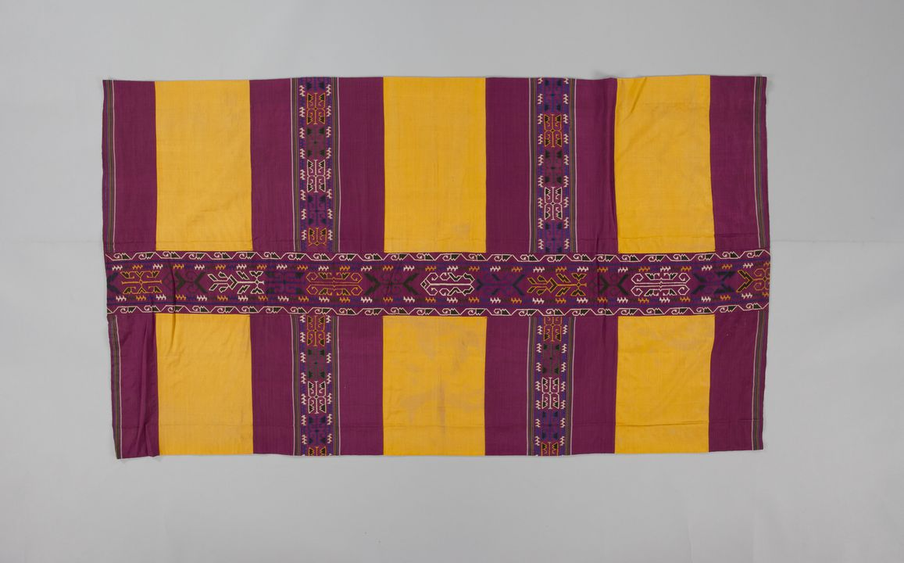

a. Malong c. Bamboo Art

b. Pagbuburda d. Hagabi

10. 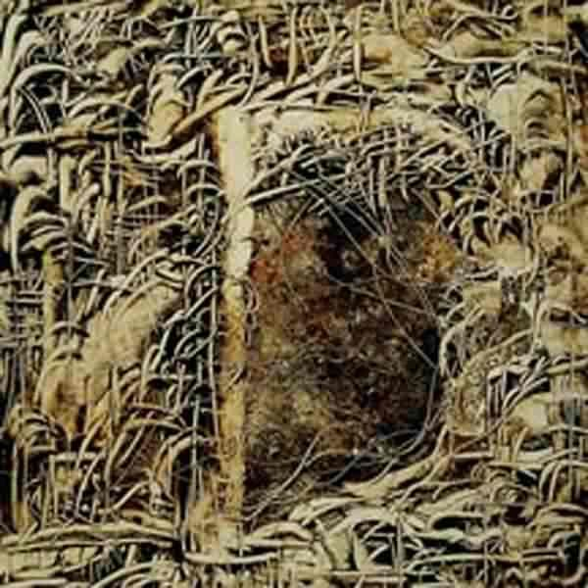

a. Kut-Kut Art c. Hagabi

b. Sarimanok d. Bamboo Art